Methods Semester 1 Exam Notes – Year 11 2023

By Ajay Bisnath

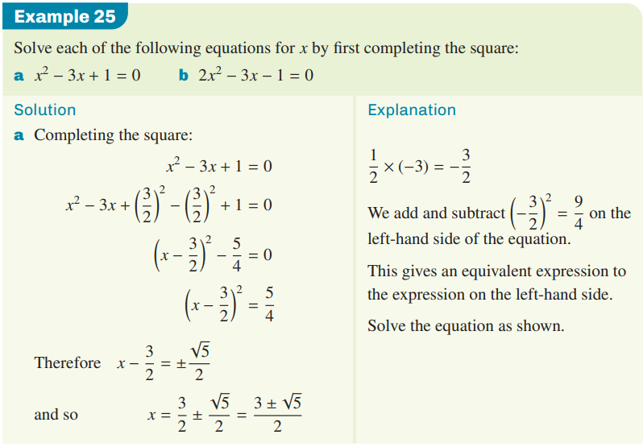

Domain 🡪 Dx: {x $ϵ R$}

or Dx: {x > 0}

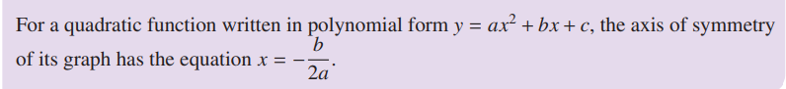

* A screenshot of a computer

  Description automatically generated with medium confidenceb2 – 4ac is the discriminant

Tells us how many x-intercepts

**Factorising by Inspection when a 1:**

2x2 + 9x + 10

2 * 10 = 20

What 2 numbers multiply to 20 and add to 9?

4 * 5 = 20, 4 + 5 = 9

4/2 = 2 🡪 (2x + 5)(x + 2)

**Graph General Equations:**

$$y=a\sqrt{x - h}+k$$

$$y = \frac{a}{x - h}+k$$

$$y = {ax}^{2}+bx + c$$

**Angle sum and Difference Identities:**

* sin(A $±$ B) = sinAcosB $±$ cosAsinB
* cos(A $±$ B) = cosAcosB $∓$ sinAsinB

**Sin, Cos and Tan Graphs:**

* **asinb(x – c), acosb(x – c)** and **tanb(x – c) + d**
* ***a*** represents the **amplitude** (how high the peak is from the centre line)
* **Period** (***b***) for all these equations is 360 degrees (2 $π$)
  + If the period graphed is 180 degrees, **b** will be ½
  + The period is from the start of one loop to the end of the loop for the equation
* 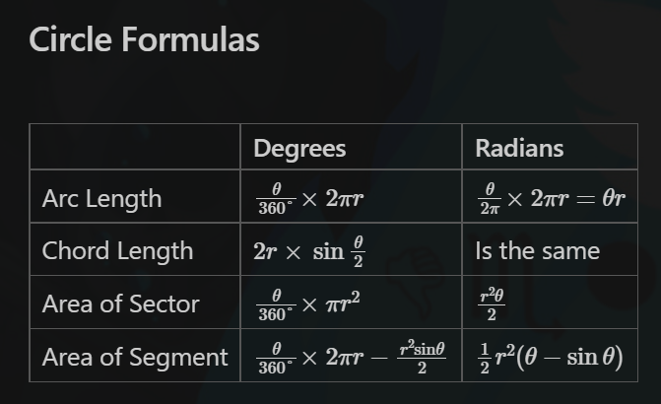***c*** **horizontally translates** the graph left and right (positive c moves to the right)

